**CASE STUDY: 04**

**Deploy any Angular Application (Template Driven Form or Reactive Form) in Jenkins**

* **Create and Run an Angular Project.**

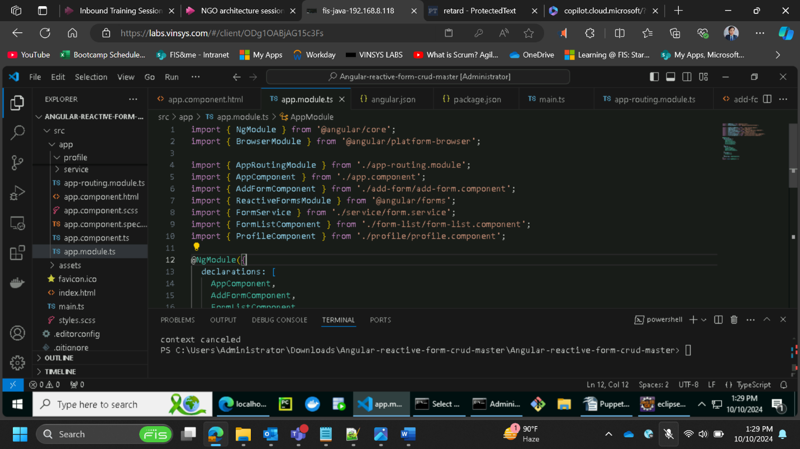

* **Set Up Jenkins and integrating it with GitHub repository**

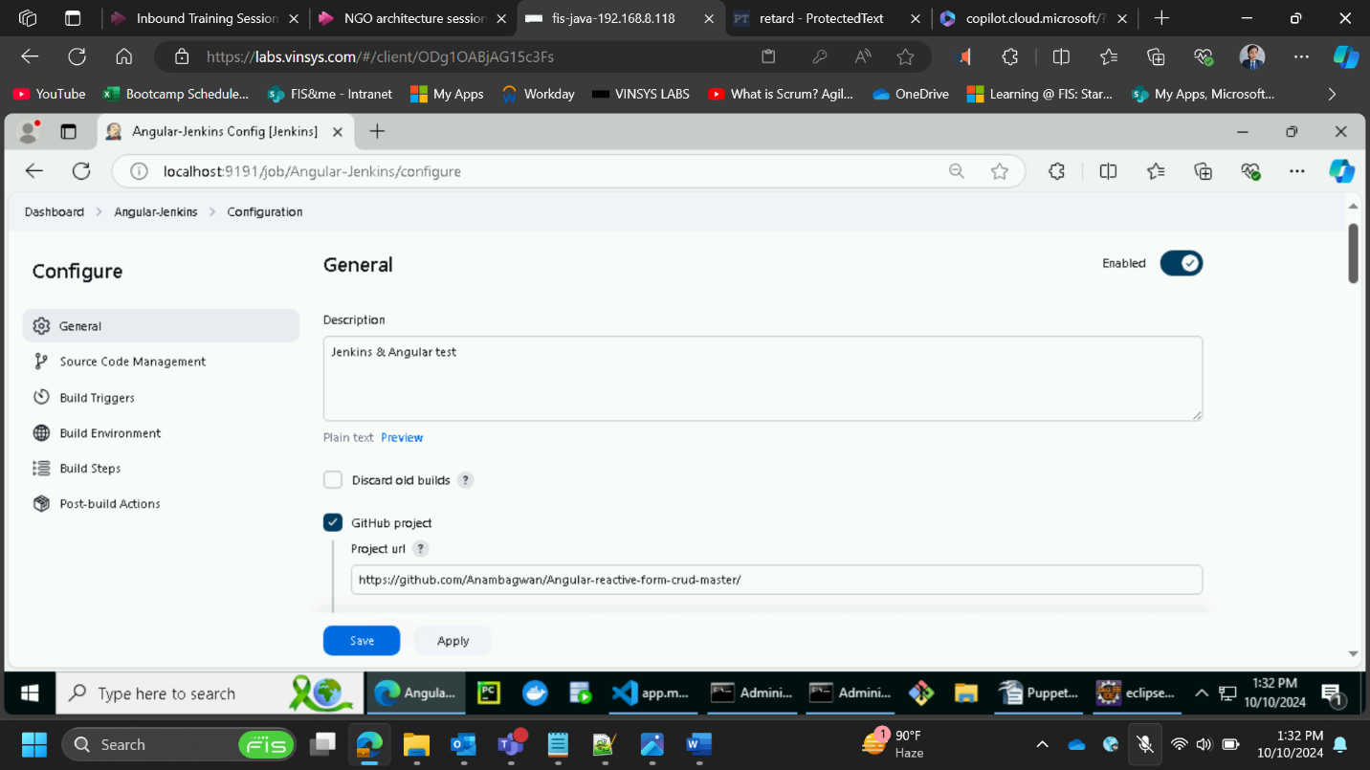

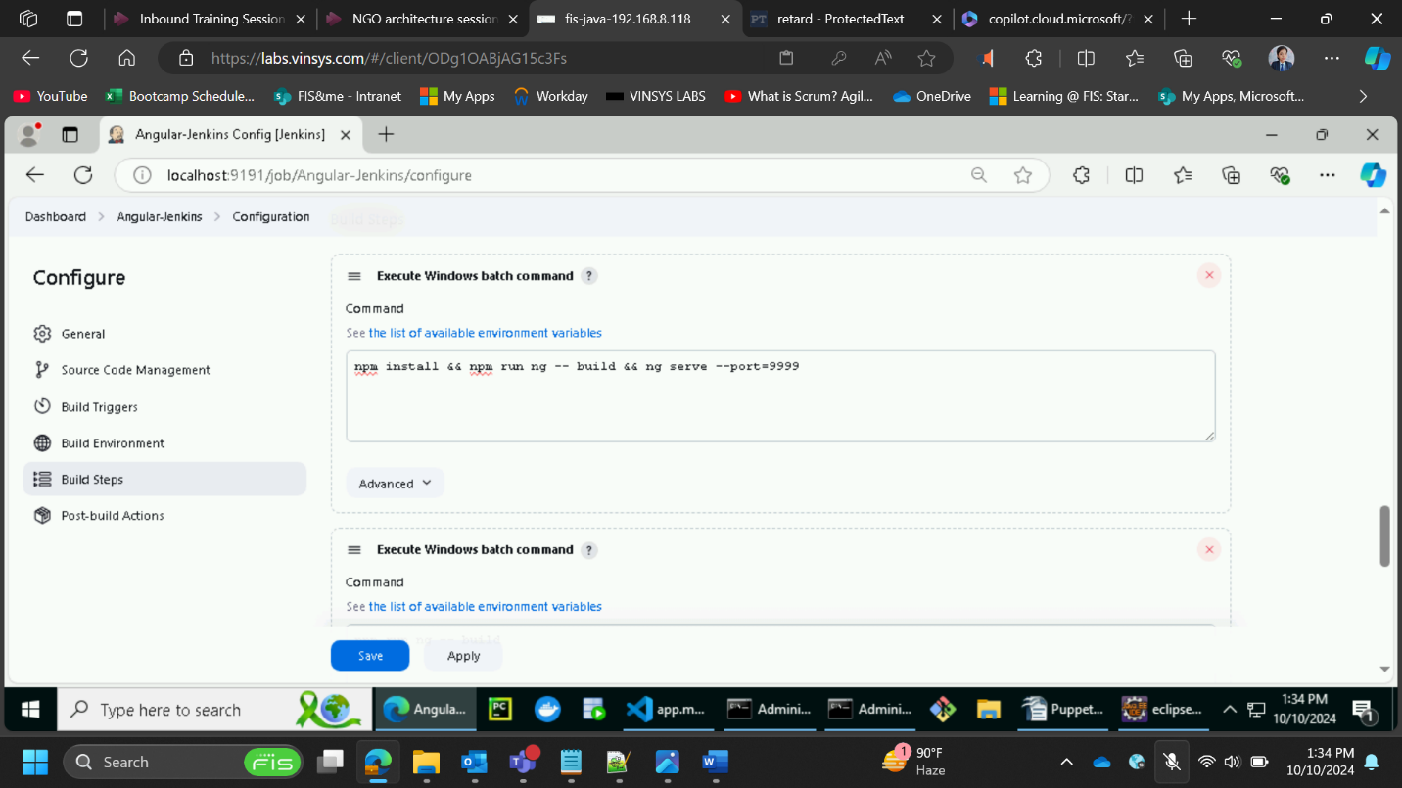

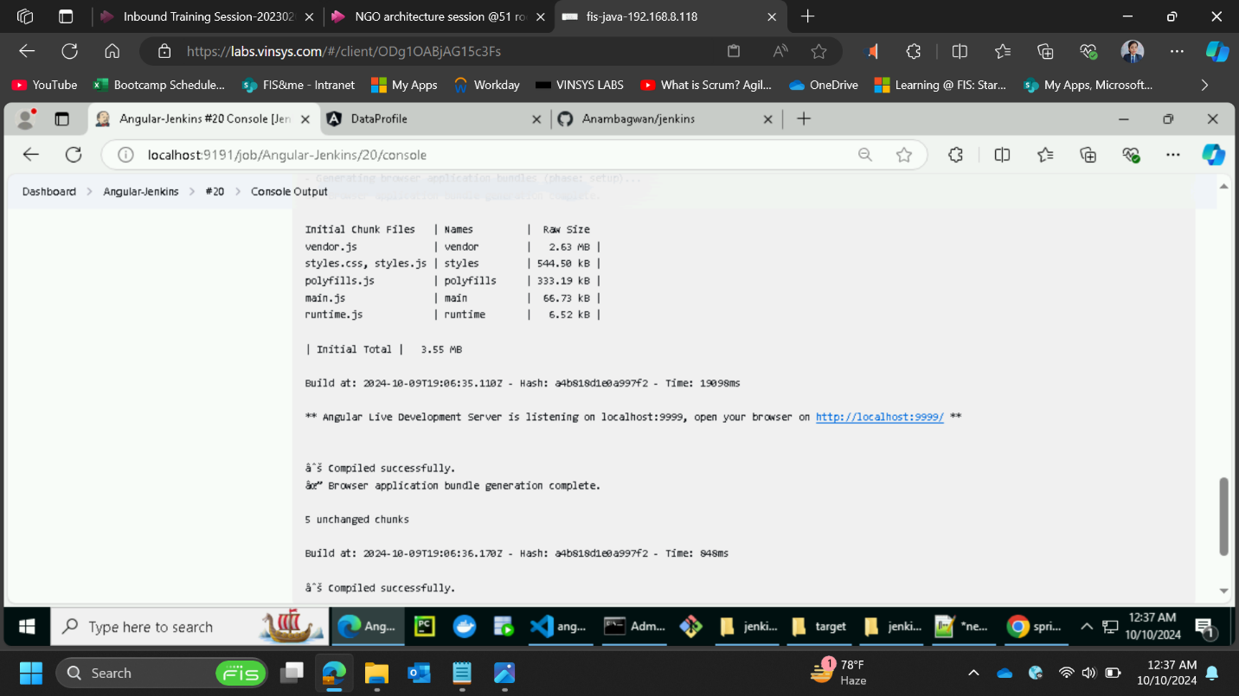

* **Run the angular app on Jenkins port specified:**

**1. Create**

**2. Update:**

**3. Retrieve:**

**4. Delete:**

